PAS-PT-1
HARSH MITTAL
BTECH CSE 4B
2K19CSUN01082

Q-1 How many chords can be drawn through 17 points on a circle?

CODE:
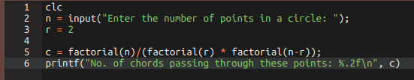

OUTPUT:

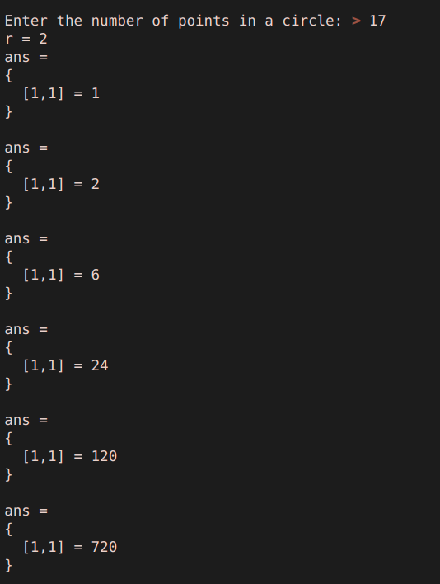
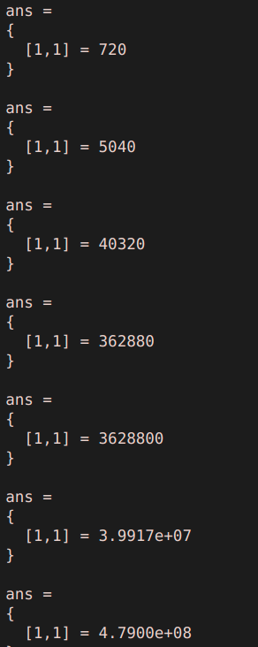

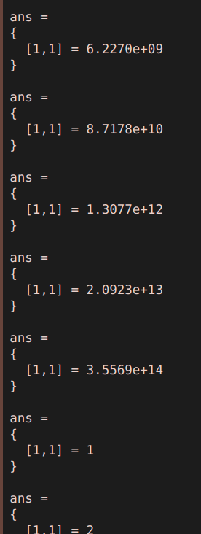
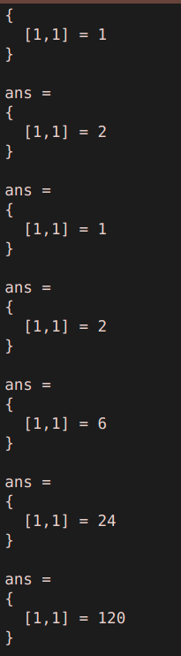
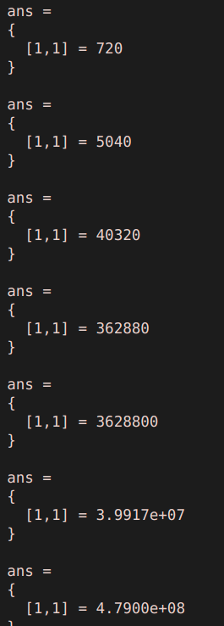

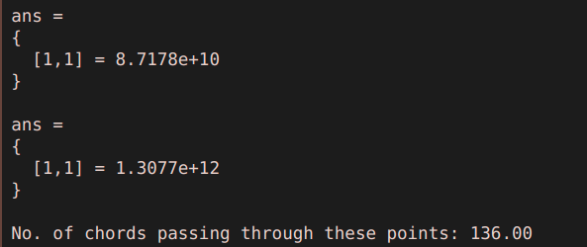

Q-2
The probability that a man aged 35 years will die before reaching 40 years may be taken 0.018. Out of a group of 400 men, now aged 35 years, what is the probability that 2 men will die within the next 5 years?

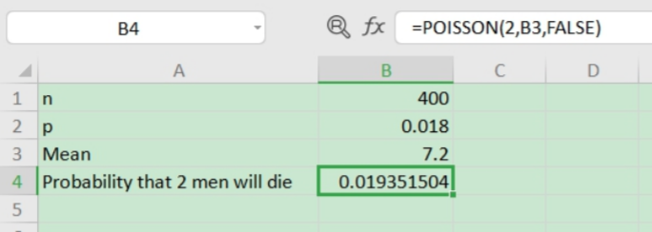
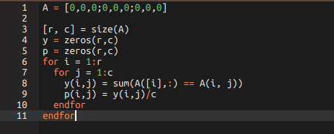
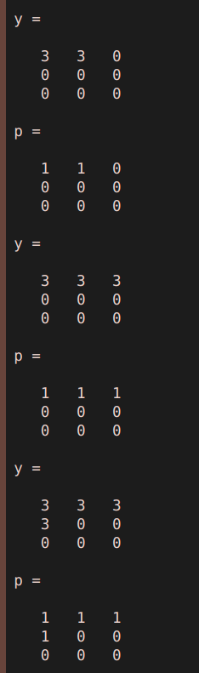

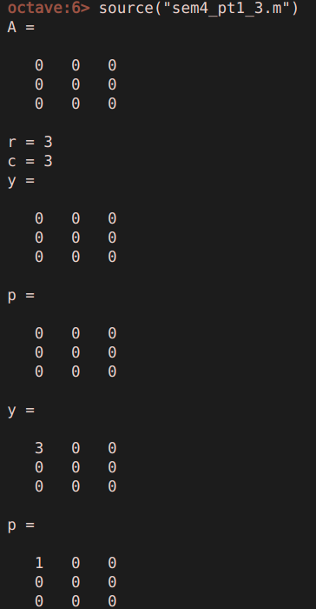
Q-3
Find probability of each element (row wise) of a Null matrix of order 8.
CODE:

OUTPUT:

Q-4

Fit a Binomial Distribution to the following data: X: 0 1 2 3 4 F: 30 62 46 10 2
